A000-Am,C-Taino-Torch Cemi-Basalt-1000 CE

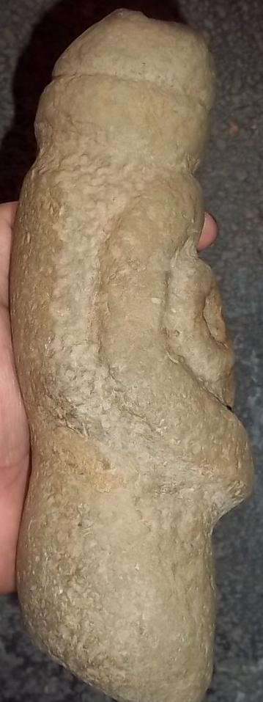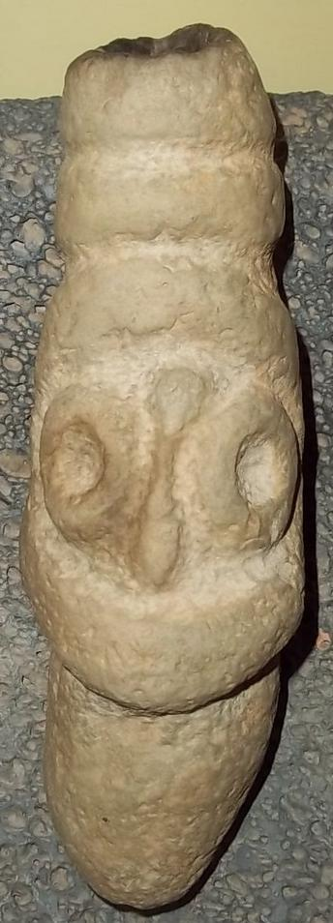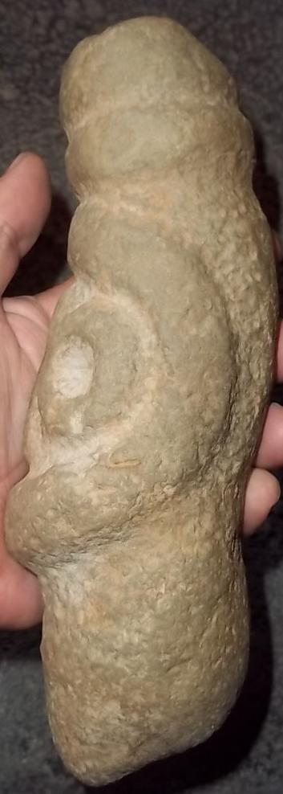

Figs1-3. Am,C-Taino-Torch Cemi-Basalt-1000 CE

Case No.: 18

**Accession No.**

**Formal Label:**

**Display Description:**

Stone Cemi figure that appears to be a torch. The cemi stone has a depression on the top which has burn marks, and the other end has a depression and fain traces of burn marks. In the Taino cosmology the upright torch would have been used for earthly ceremonies while the torch held upside-down would have been used in underworld ceremonies as the holder of the torch entered a cave sanctuary.

**LC Classification: F1909**

**Date or Time Horizon: 1000 CE**

**Geographical Area: E Hispaniola, i.e., Dominican Republic.**

**Map:**

**GPS coordinates:**

**Cultural Affiliation: Taino**

**Medium: Basalt**

**Dimensions:** 10 in. x 5 1/4 in.x 3 1/2 in.

**Weight:** The weight is almost six pounds.

**Condition: original**

**Provenance:** It was brought back from the Dominican Republic in the 1960's.

**Discussion:**

**References:**

Appendix: additional views.

